**Biometric Installation in Drug De-Addiction Registry Portal**

1. Please visit the UIDAI website to check list of registered Biometric Devices. [**https://uidai.gov.in/images/Fingerprint_L1_RD_Devices_14_09_2023.pdf**](https://uidai.gov.in/images/Fingerprint_L1_RD_Devices_14_09_2023.pdf)
2. Please purchase any device from above given url.
3. Download and install the Drivers & RD services with respect to your device models which you will purchase.
4. You need to download the Drivers & RD services online from vendor website like **For mantra you can download from (**[**https://www.mantratec.com/Download/User**](https://www.mantratec.com/Download/User)**)**
5. After install the Drivers & RD services on computer, you need to restart your computer.
6. After connecting the biometric device, you can check the device and capture status in this link <https://rdtest.aadhaardevice.com/>
7. If there is any issue regarding starting of RD services, then you can also restart the RD services as mentioned in below screenshot.

Windows Key + R -> Type **services.msc** and the press OK

1. After press OK, below given screen will open and then you need select device and Right Click and then restart like as given in below screenshot.

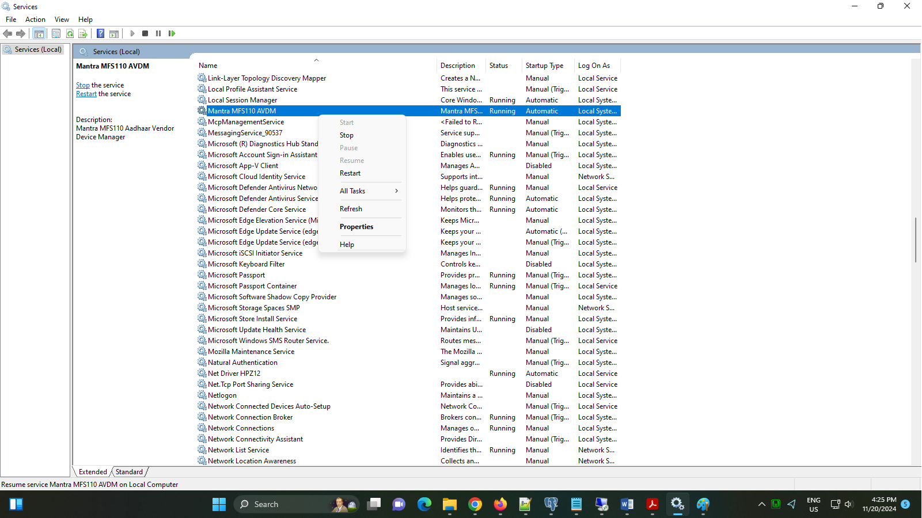

1. After click on Restart button it will take few seconds to restart and biometric device will start to work now.

Thank You!